**BIKE SHOWROOM SYSTEM**

**TEAM MEMBER**

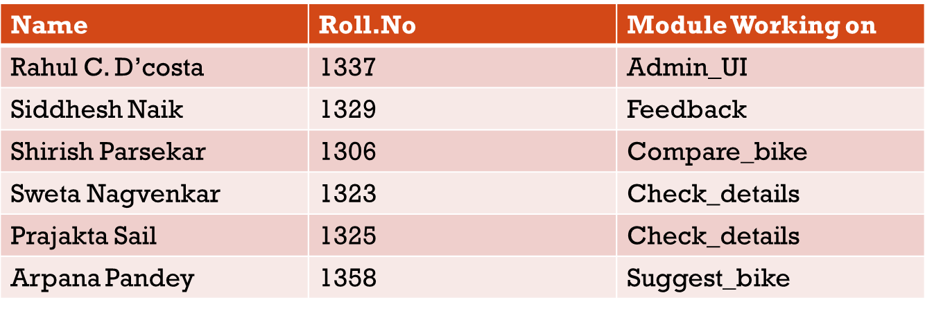

**Packages Required**

1. **Wish**: is a simple program consisting of the Tcl command language, the Tk toolkit, and a main program that reads commands from standard input or from a file. It creates a main window and then processes Tcl commands.

**Command to install wish package:** $sudo apt-get install tk

1. **Packages Required For Database.**
2. Mysqltcl

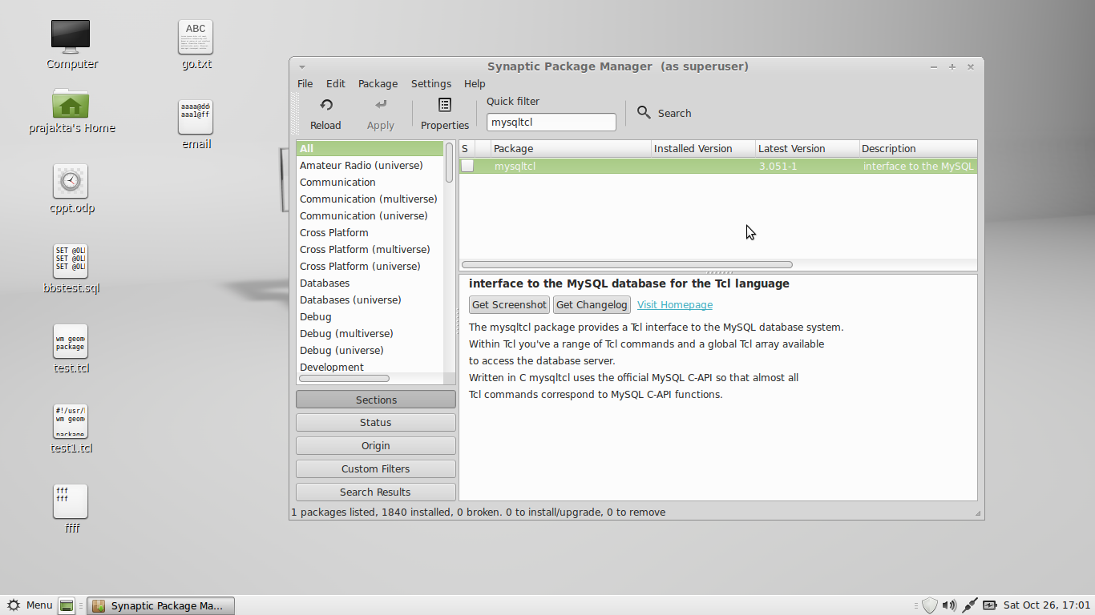

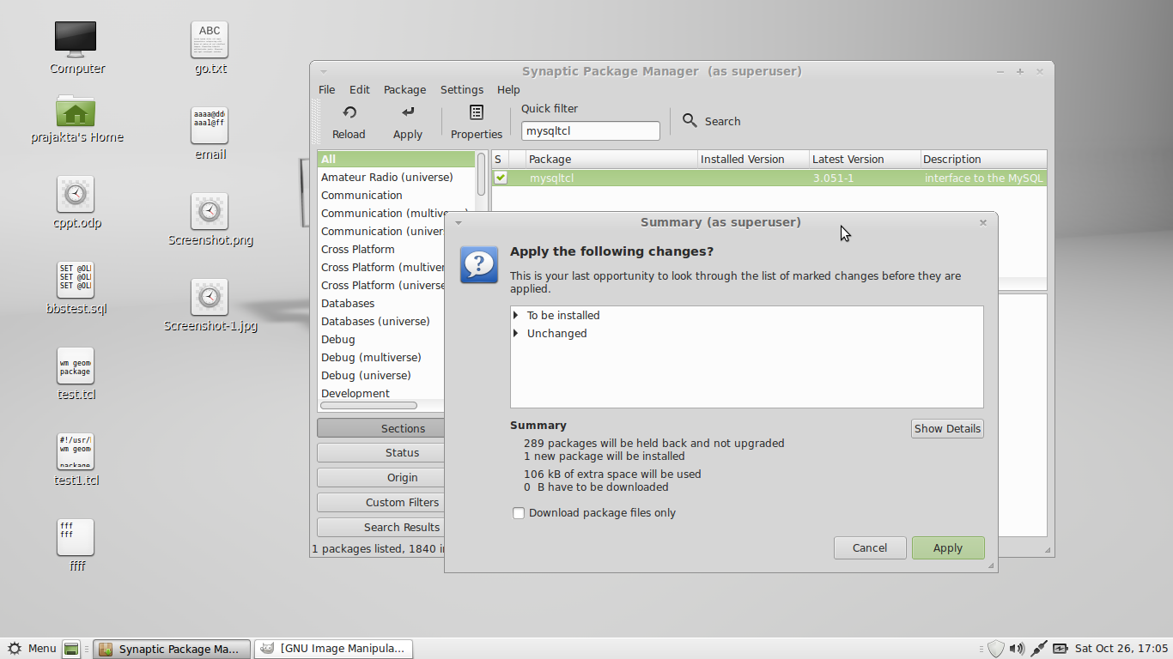

1. Mysqlserver

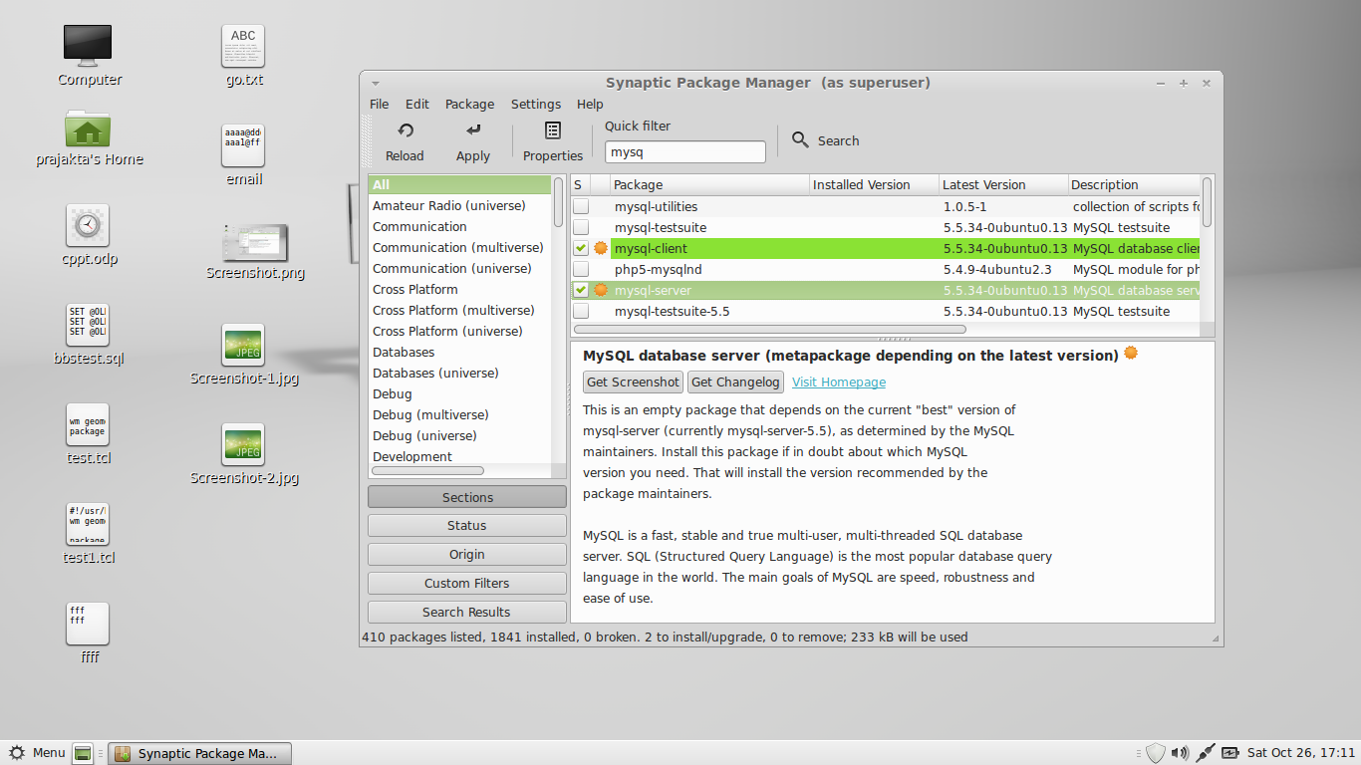

1. Mysqlclient

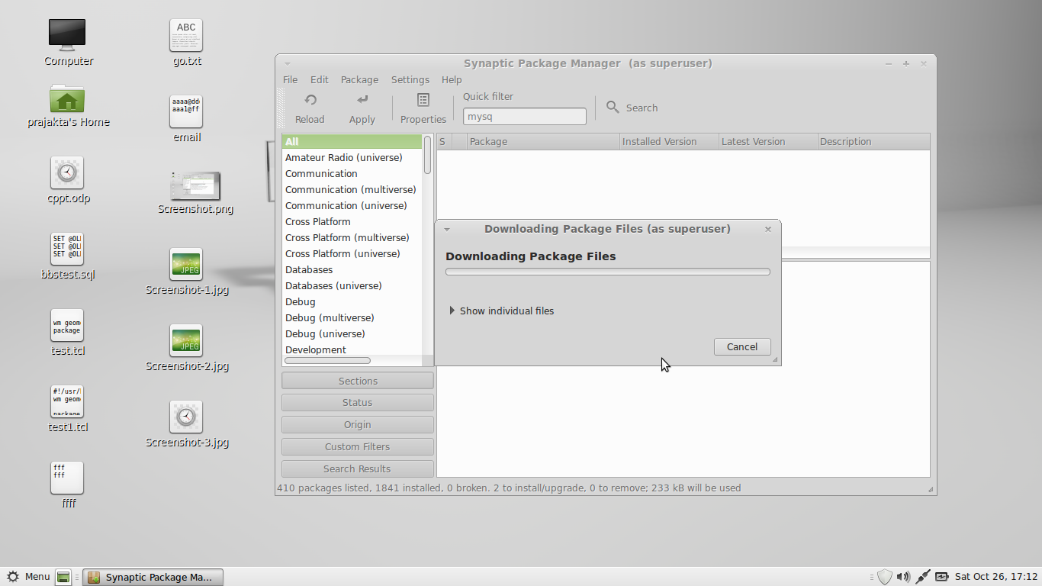

Install mysql client, mysqltcl pacakge and mysqlserver in Fedora or Linux Mint using the package manager.(As shown in the images).

Than run on command line: **mysql -uroot -hlocalhost -p (-u for user, -h for host and –p for password)** **<mysql> source bbstest.sql ;** the database with tables will automaticaly get created.

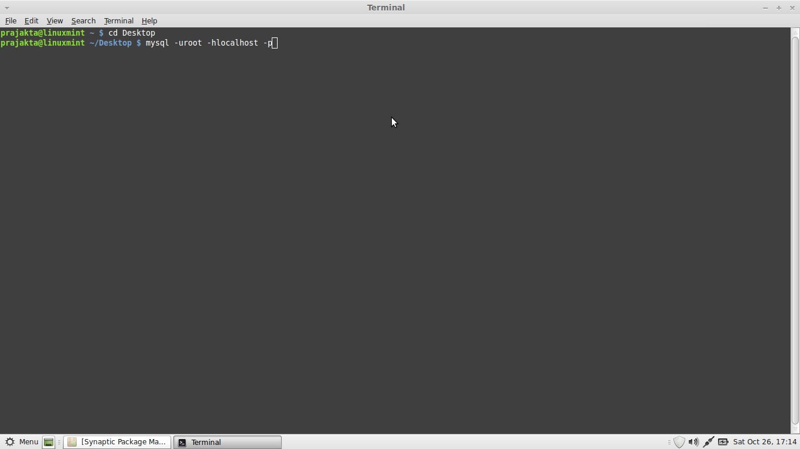

**4.TkImg for Displaying Images**

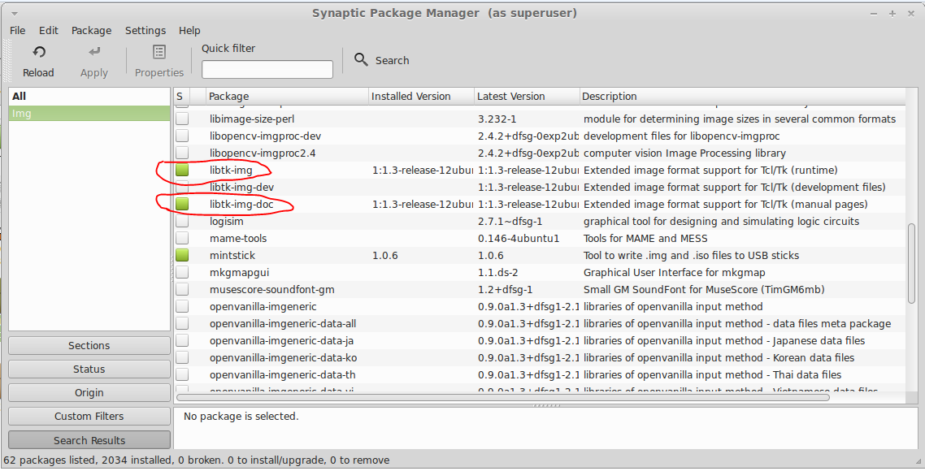

**Command to run the file:** wish filename.tcl

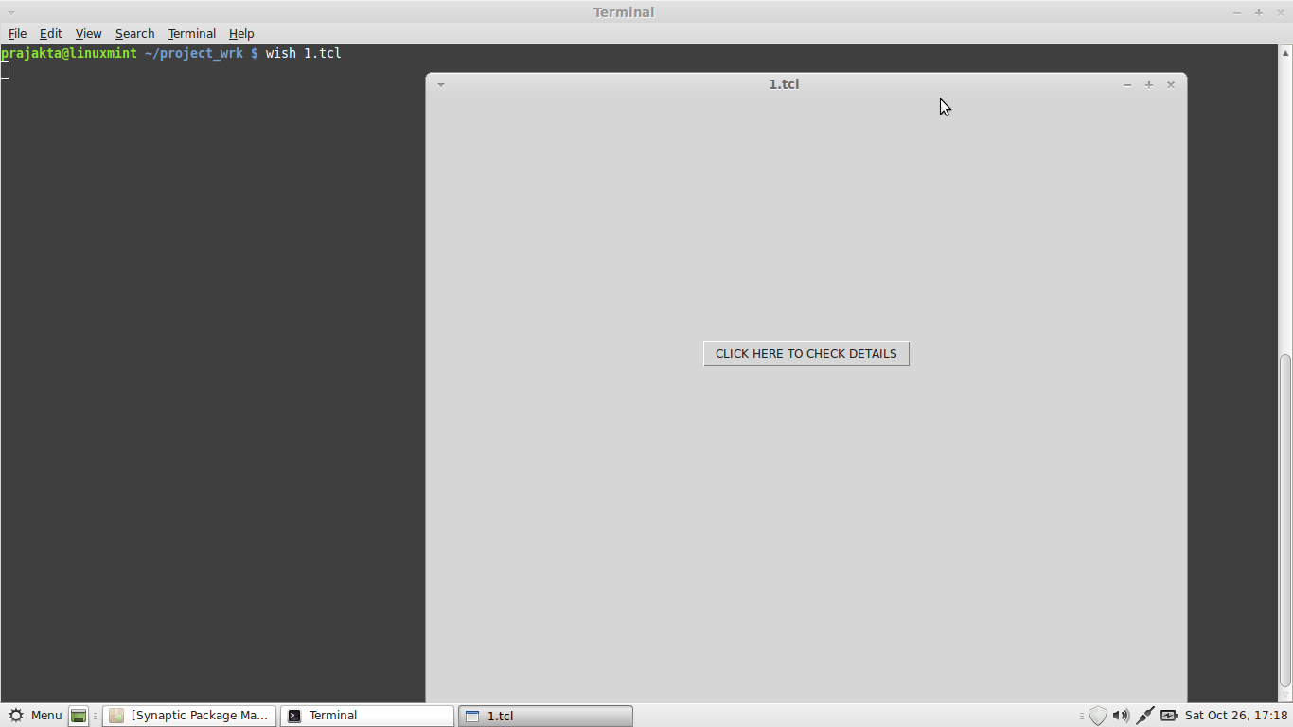

**Module Wise Input And Output**

1. **Check_Detail** Input: Bike_Name Output: Details of the Bike
2. **Feedback**

Input: Name, Age, Bike_Name, User feedback, Comments.

Output: Name, Overall User Satisfaction, Comments.

1. **Compare_Bike**

Input: Bike_Names

Output: Bike Details

1. **Suggest_Bike**

Input: User information

Output: Bike_Names

1. **Admin_UI**

Input:userid,userpasswd ,operation choice

Output: add,view,update,delete functions of records to the Database

**Note:- The Login For Admin Is Static,Later we will make it Dynamic. Login Details**

**Username :- admin**

**Password :- nopass**

**Run the Main File ncoderz.tcl**

**Like this --🡪 wish ncoderz.tcl,all other files are required. Within the Ncodez Folder**

**The Displaying of Different Bike based on the type of bike Cannot be done static. Because every time the path changes  
/home/anyuser/Ncoderz/BAJAJ/*.jpg**

**On every system the anyuser will be different so no permanent pathway..  
just to show that we can display images in tcl tk we have kept same images for the all the bikes.**

**Also the Suggest Bike Module will show result on Pattern AAAAA, only a few pattern entry have been done by Aprana Pandey**

**Also Try to Upload the Photo in 320 X 190 resolution..make use of the footosizer application in the zip file.**

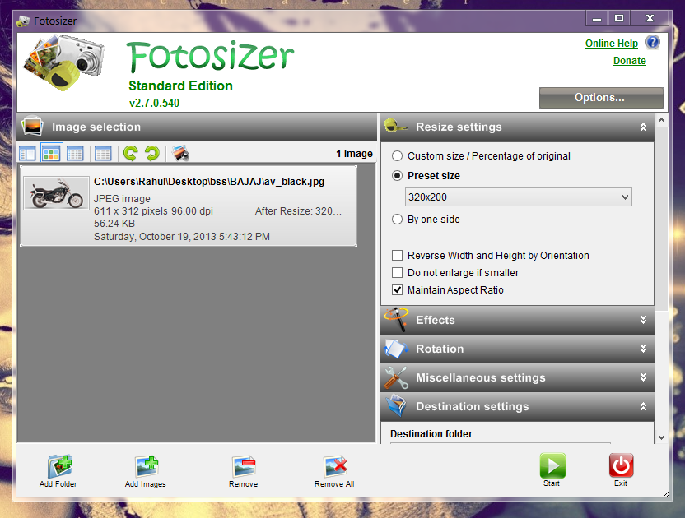

**Reference**

**Tutorial Videos By Rani Ahmad**

<http://pages.cpsc.ucalgary.ca/~saul/personal/archives/Tcl-Tk_stuff/tcl_examples/>

<http://www.tutorialspoint.com/mysql/index.htm>

<http://www.artfulsoftware.com/infotree/queries.php>

<http://www.icanprogram.com/09tk/lesson2/lesson2.html>

<http://www.bin-co.com/tcl/>

<http://www.tcl.tk/>